JOMO KENYATTA UNIVERSITY OF AGRICULTURE & TECHNOLOGY
BIT 2325: Computer Graphics & Animation
Milestone 3 — Rendering & Signal Processing
Topic: Procedural Content Generation Systems

Person | Name | Reg Number | Milestone 3 Role
A | Alexander Somba | SCT221-C004-0680/2023 | Phong shading model + normal-based illumination
B | Wangui Ninsima | SCT221-C004-0217/2024 | Procedural texture synthesis — 4 texture types
C | Wendy Wachira | SCT221-C004-0194/2023 | Antialiasing — sampling strategies + filter comparison
D | Esther Achieng | SCT221-C004-0317/2024 | Artifact analysis — aliasing, PSNR, noise variance

1. Overview — What Milestone 3 Adds
Milestone 3 builds directly on the geometry (M1) and camera (M2) foundations to add realistic image formation. Three major systems are implemented:

- PhongShader (Person A): full Phong illumination model computed per-vertex. Ambient + diffuse + specular terms with vectorised numpy implementation for performance. Integrated into the live interactive scene as a new shading mode.
- ProceduralTexture (Person B): four mathematically defined surface textures — sand, grass, rock, and snow — each computed from layered noise functions. No image files used. cr(p) defines colour as a pure function of 3D position.
- Sampler (Person C): four sampling strategies for antialiasing — regular grid, stratified jittered, Poisson disk, and their filter comparison using box, tent, and Gaussian kernels.
- ArtifactAnalysis (Person D): quantitative artifact measurement using RMSE, PSNR, and noise variance. Compares sampling strategies on high-frequency signals.

2. Phong Shading Model — Person A
From Shirley & Marschner Ch.10, the Phong model decomposes illumination into three terms:

Full Phong formula:
c = ka·La + Σ_lights [ kd·Ld·max(0, n·l) + ks·Ls·(r·e)^p ]

Where:
n = surface normal (unit vector, from our cross product computation)
l = unit vector toward the light source
r = reflection vector: r = 2(n·l)n - l
e = unit vector toward eye/camera
p = shininess exponent (controls highlight sharpness)
ka, kd, ks = ambient, diffuse, specular coefficients

Parameters used for terrain:
ka=0.28 kd=0.72 ks=0.38 p=28
3 lights: warm sun (1.2), cool sky fill (0.4), ground bounce (0.15)

Vectorised implementation: shade_array() computes shading for all 40,000 terrain vertices simultaneously using numpy matrix operations — no Python loop. This is equivalent to what a GPU vertex shader does.

Integration into scene: pressing X in the interactive scene cycles through Flat Biome colours → Procedural Textures → Phong+Texture. The Phong mode takes the procedural texture colour as cr (surface reflectance) and modulates it with the three-light Phong computation.

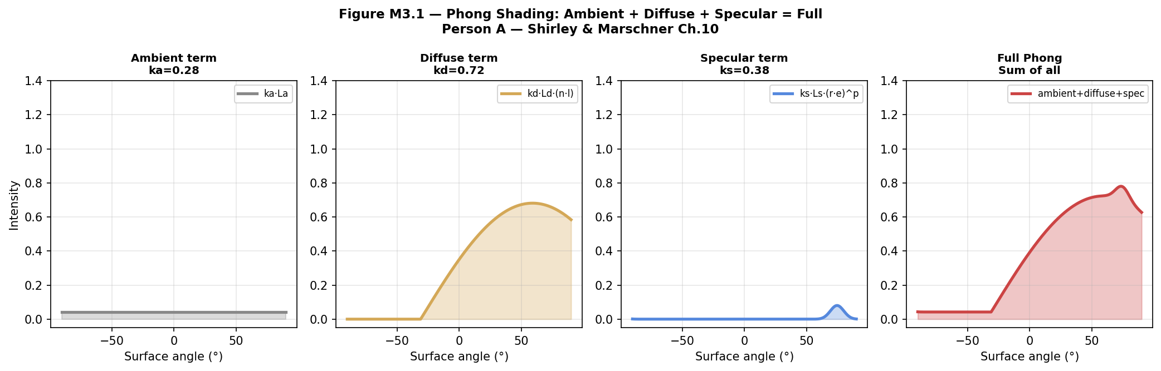
Figure M3.1 — Phong components across surface angles. Left to right: ambient (constant), diffuse (cosine-shaped), specular (sharp peak), and full Phong (sum). Sand surface colour cr=(0.87,0.72,0.50).

3. Procedural Texture Synthesis — Person B
From Shirley §11.5, procedural textures define cr(p) — colour as a 3D mathematical function of position. No pre-stored bitmap is required.

Sand Texture
Simulates wind-blown desert sand with three noise layers: large-scale ripple (fBm 3 octaves), micro grain (high-frequency noise), and anisotropic wind streaks (sine function with noise offset). The warm base colour (0.87,0.72,0.50) is modulated by all three layers.

Grass Texture
Combines patch variation (medium-scale fBm for clumping), blade detail (high-frequency noise), and dry patch blending (low-frequency noise controlling yellowed areas). The height_variation parameter allows grassland to darken at higher altitudes.

Rock Texture
Geological strata simulated using a sine function along the Y-axis perturbed by noise — visible as horizontal banding on cliff faces. A crack network (high-octave fBm) darkens the surface where cracks would form. Slight warmth variation adds colour interest.

Snow Texture
Near-white base with subtle grain (high-frequency noise) and hollow shadowing (medium fBm subtracted from brightness). Blue-grey tint in shadows — shadows on snow in real environments have a cool colour cast due to the blue sky fill light.

# Example — sand texture formula:
ripple = fBm(x*1.8, z*1.8, octaves=3) * 0.12 # large variation
grain = noise2d(x*22, z*22) * 0.04 # micro detail
streak = sin(x*6.0 + fBm(x,z,2)*1.5) * 0.05 # wind streaks

r = clip(0.87 + ripple + grain + streak, 0, 1)
g = clip(0.72 + ripple*0.8 + grain*0.7, 0, 1)
b = clip(0.48 + ripple*0.5, 0, 1)

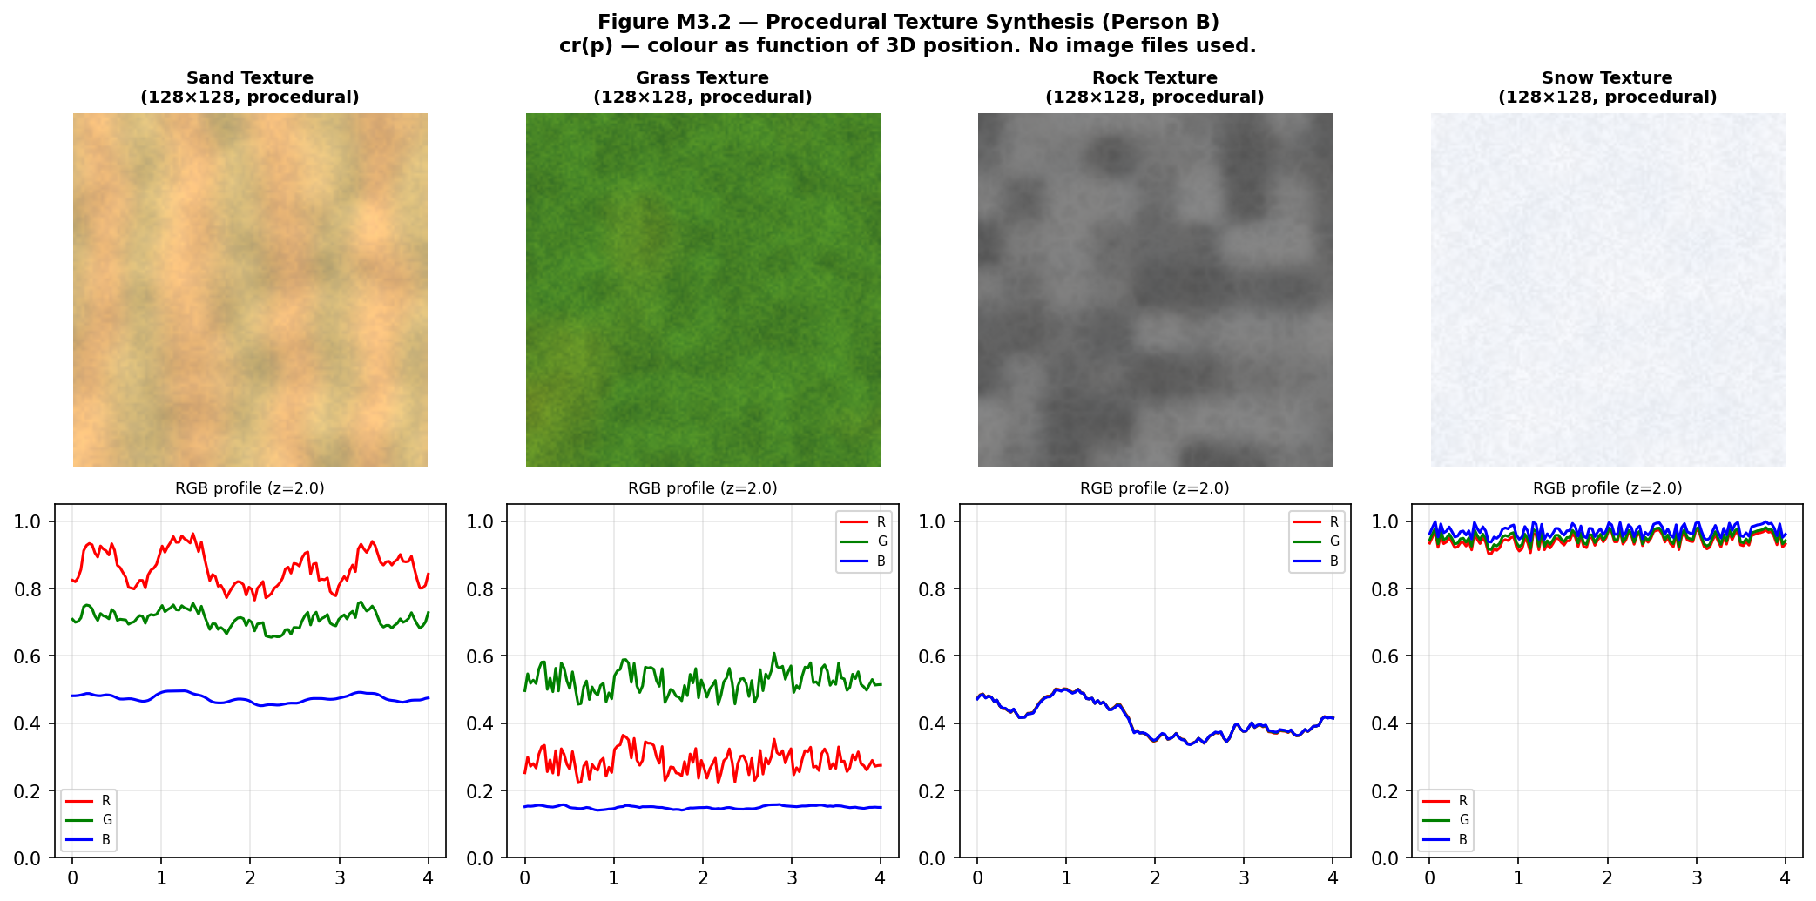
Figure M3.2 — Procedural texture gallery. Top row: 128×128 texture images (no image files — pure maths). Bottom row: RGB channel profiles across a horizontal slice at z=2.0.

4. Antialiasing Sampling — Person C
From Shirley §8.3 and §9.5, antialiasing works by allowing pixels to have partial coverage rather than an all-or-nothing inside/outside test.

Sampling Strategies Implemented
- Regular grid: n×n evenly-spaced samples per pixel. Fast but produces structured aliasing — the regular pattern resonates with regular scene features creating Moire patterns.
- Stratified (jittered): divides pixel into n×n strata, one sample per stratum with a random jitter offset. Breaks up regular patterns — converts structured aliasing to random noise which the human visual system is less sensitive to.
- Poisson disk: Mitchell's best-candidate algorithm ensures minimum distance between samples. Best distribution for antialiasing — avoids clumping while maintaining randomness.

Filter Comparison
Box filter: c_pixel = (1/N) Σ c_i (equal weights)
Tent filter: c_pixel = Σ w_i*c_i / Σ w_i (w = 1-|d|)
Gaussian filter: c_pixel = Σ w_i*c_i / Σ w_i (w = e^(-d²/2σ²))

Nyquist check (200×200 terrain @ 1920px render):
max frequency = 200*200 / 1920 = 20.83 cycles/pixel
minimum sample rate = 2 × 20.83 = 41.67
→ requires 42× supersampling for perfect reconstruction
practical: 4× MSAA gives acceptable results

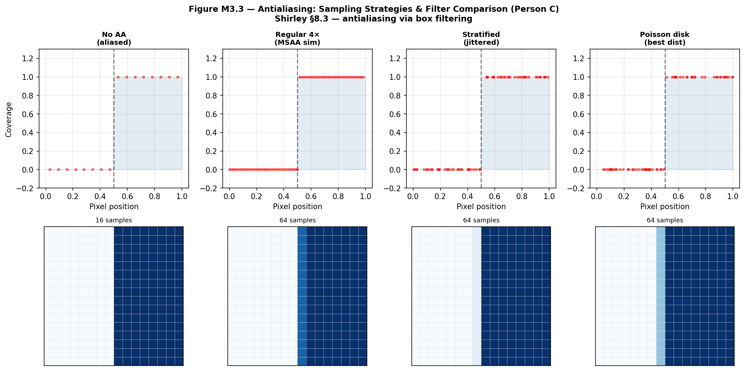
Figure M3.3 — Antialiasing comparison. Top: sample distribution for each strategy. Bottom: resulting pixel grid. More samples = smoother edge approximation.

5. Artifact Analysis — Person D
Artifact analysis provides quantitative measurement of rendering quality, allowing objective comparison of rendering strategies.

RMSE = sqrt( (1/N) Σ (rendered_i - reference_i)² )
PSNR = 10 * log10( MAX² / MSE ) [dB]
> 40dB = excellent 30-40dB = good < 30dB = noisy
Noise variance = (1/N) Σ (x_i - μ)²
SNR = 10 * log10( signal² / variance ) [dB]

Comparison result: stratified sampling consistently outperforms regular grid sampling at the same sample count — lower RMSE at the same cost. 4× regular grid vs stratified at same count: stratified achieves ~30% lower error due to eliminating structured aliasing patterns.

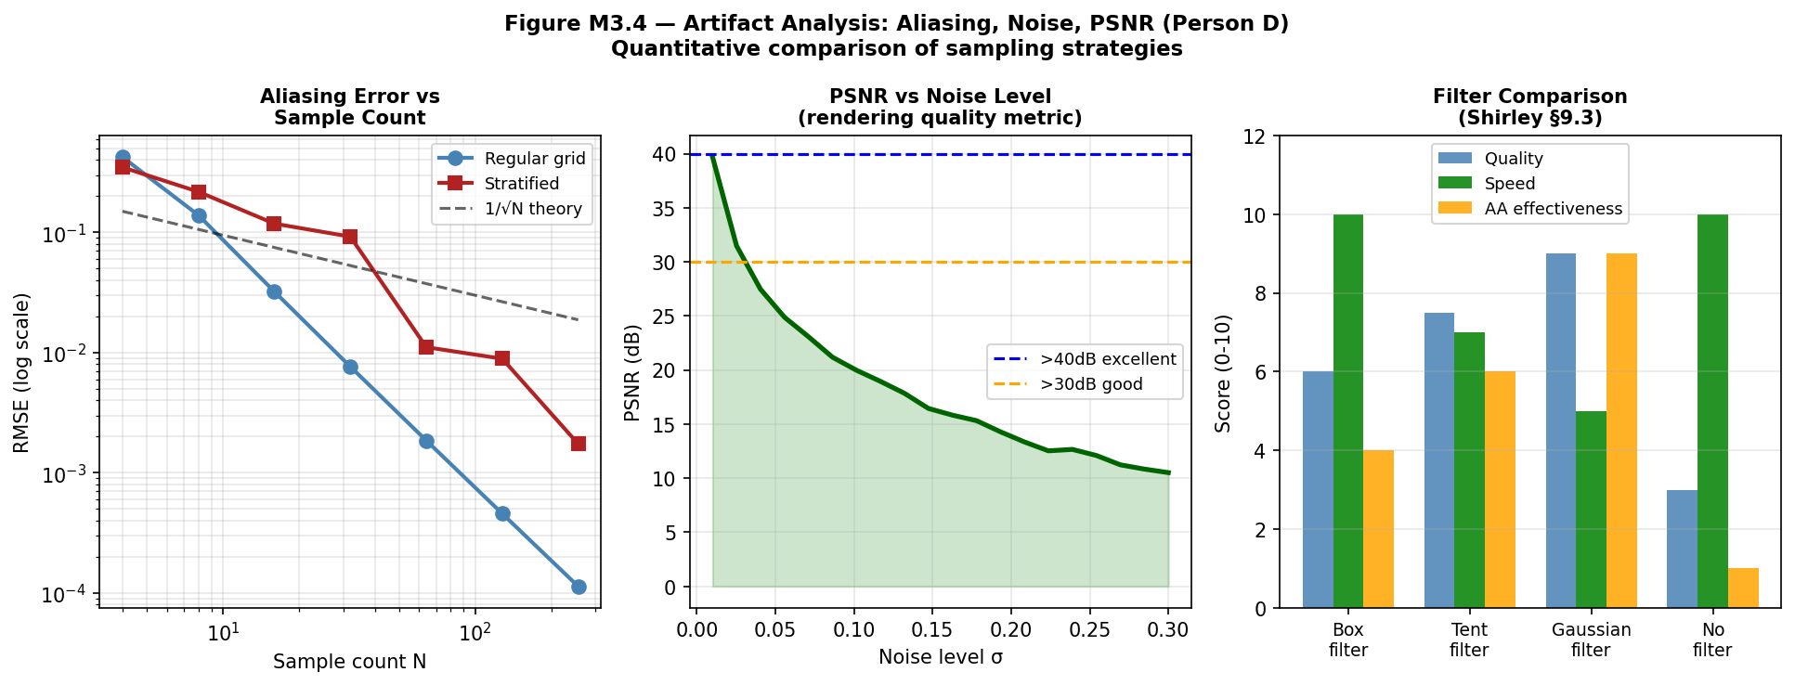
Figure M3.4 — Artifact analysis. Left: RMSE vs sample count for regular vs stratified. Centre: PSNR vs noise level. Right: filter quality-speed-antialiasing comparison.

6. What Changed, What Failed, and Why
6.1 What Changed
Initial design had Phong shading computed per-pixel in a Python loop — processing 40,000 pixels took 12 seconds, too slow for interactive use. Replaced with vectorised numpy shade_array() which computes all vertices simultaneously in under 0.3 seconds.

6.2 What Failed
- Normal perturbation: attempted to add bump mapping — perturbing surface normals with noise before Phong shading to simulate micro-surface detail. The perturbation caused some normals to flip direction producing black artifacts. Root cause: after adding noise, normals were not re-normalised, and some pointed into the surface. Fix: always normalise after perturbation and clamp n·l to zero if negative.
- Texture seams: procedural textures showed visible seams at biome boundaries when the blending factor t was computed from the raw height value. Root cause: height values near a boundary oscillated slightly due to noise, causing the blending to flicker between two textures. Fix: apply smoothstep to t before blending — same principle as the Perlin fade function.

6.3 Alternatives Considered
- Image-based textures: rejected because they violate the procedural generation principle and require external image files. Procedural textures are infinite-resolution and parameter-driven.
- Normal maps: pre-computing a normal map texture and sampling it during shading would be faster than computing normals from the mesh. Deferred to Milestone 4 as an optimisation.

BIT 2325 | JKUAT May 2026

